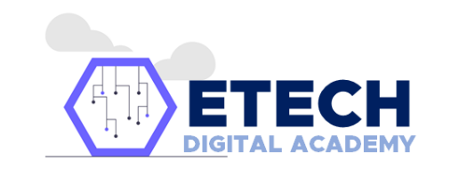
DIGITAL ACADEMY SUMMIT 2021
Corporate Head Office
Unit 143 The One Ventura Building,
E. Nadal Road corner Tabbu, Guerrero Center
Kuala Lumpur, Malaysia
Telephone: (+63) 844-6236
WhatsApp: 20212020
Website: EtechDigitalAcademy.com.ph

September 03, 2021

«Title» «First_Name» «Last_Name»
«Address_1», «Address_2»
«City», «Code»

Dear «Title» «Last_Name»

Greetings from E-Tech Digital Academy! CONGRATULATIONS!

We are pleased to inform you that you have been SELECTED for the upcoming Digital Academy Summit 2021 in Malaysia, 15th - 18th November 2021. Considering this,

Digital Academy Summit 2021 is a global digital literacy program that aims to help people think critically and share thoughtfully online. It is designed to help Filipinos with vital skills, such as critical thinking, empathy and being adept at using tools for online safety and well-being.

Here are some important things that the participant should know:

1. Each participant will be responsible for their visa and flight trip to and from Kuala Lumpur International Airport.
2. Check in Hotel at 03.00 PM on Sunday, 14th November 2021 and check out must be done before 12:00 PM on Friday, 19th November 2021.
3. The committee will provide the accommodation such as hotel, meals, and local transportation for participants during the event.
4. It is mandatory to pack the items listed below prior to your departure:
- Valid Passport;
- Flight ticket;
- Visa (if required)

In addition to this, we would like to schedule an initial conversation with you and our team. You will be speaking with Ms. Josephine Guerrero, our Project Manager, and Ms. Marinel Tabbu, our Project Support. The interview will last approximately 15 minutes.

Thank you for your kind attention and cooperation.

We’re looking forward to meeting you in Malaysia!

Have a nice day!

Regards,
Jericho R. Dela Cruz
Media and Communication Director
E-Tech Digital Academy
